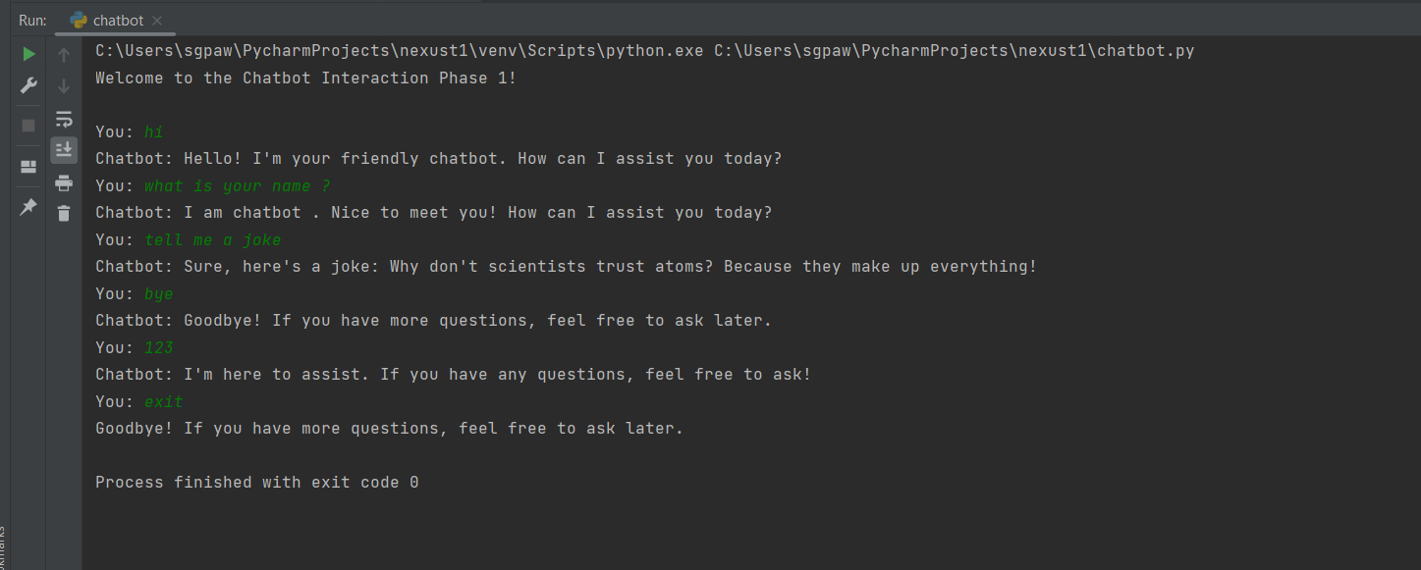

# Function to greet the user  
def greet_user():  
 return "Hello! I'm your friendly chatbot. How can I assist you today?"  
  
# Function to provide a farewell message  
def farewell_message():  
 return "Goodbye! If you have more questions, feel free to ask later."  
  
# Function to handle user input and generate appropriate responses  
def handle_user_input(user_input):  
 # Convert user input to lowercase for case-insensitive matching  
 user_input_lower = user_input.lower()  
  
 # Check for greetings  
 if "hello" in user_input_lower or "hi" in user_input_lower:  
 return greet_user()  
  
 # Check for farewells  
 if "goodbye" in user_input_lower or "bye" in user_input_lower:  
 return farewell_message()  
  
 # Check for inquiries about the user's name  
 if "name" in user_input_lower:  
 return "I am chatbot . Nice to meet you! How can I assist you today?"  
  
 # Check for requests for jokes  
 if "joke" in user_input_lower:  
 return "Sure, here's a joke: Why don't scientists trust atoms? Because they make up everything!"  
  
 # Default response for other inputs  
 return "I'm here to assist. If you have any questions, feel free to ask!"  
  
# Main function to initiate the chatbot interaction  
def main():  
 print("Welcome to the Chatbot Interaction Phase 1!\n")  
  
 # Continuous interaction loop  
 while True:  
 # Get user input  
 user_input = input("You: ")  
  
 # Ignore empty input  
 if not user_input:  
 continue  
  
 # Check for the exit command  
 if "exit" in user_input.lower():  
 print(farewell_message())  
 break  
  
 # Process user input and get bot response  
 bot_response = handle_user_input(user_input)  
  
 # Print bot's response  
 print("Chatbot:", bot_response)  
  
# Run the main function when the script is executed  
main()